CHAPTER 1
- INTRODUCTION
Mobility and everyday activities are significantly hampered by visual impairment. Walking canes and other traditional assistive aids only offer a limited amount of help and necessitate direct contact with barriers. Smart wearable solutions that improve navigation through sensor-based feedback systems have been established as a result of technical improvements to solve these issues.This project suggests a wearable smart gadget that uses ultrasonic sensors and a Raspberry Pi to help people with vision impairments identify impediments. The gadget works by continually looking around for items that are close by and sending out real-time notifications through haptic or audio stimulation. This technology is small, user-friendly, and hands-free, in contrast to traditional methods. The goal of this project is to create a novel and affordable mobility assistance that greatly improves the quality of life for people with visual impairments by utilizing embedded systems and Internet of Things components.
Visually impaired individuals face significant challenges when it comes to mobility, as the loss of their sight severely limits their ability to engage in activities. They often rely on blind navigation systems or their memory of exploring an area. A device designed to aid in their mobility is comprised of glasses, a centrally mounted obstacle detection module, a processing unit, an output device (such as a beep component), and a power supply. The obstacle detection module and output device are connected to the processing unit, which is powered by the power supply. The obstacle detection module consists of an ultrasonic sensor, which scans up to 5-6 meters within a 30-degree range in the direction the person is walking. The sensor detects obstacles and sends a signal to the device, which generates an automated voice message in a headset attached to the person's ear, alerting them to the obstacle. This device provides visually impaired individuals with greater independence and confidence in their mobility, allowing them to navigate through their surroundings more easily. In this project, smart glasses should help blind people reach their destinations on their own. The reason it's so reliable is that it's developed on the Android operating system, and Android-based feedback, alerting them to any obstacles in their path. The use of ultrasonic glasses for the blind has revolutionized mobility for visually impaired individuals, providing them with a greater sense of independence and freedom to explore their surroundings with confidence. The technology has the potential to greatly enhance the quality of life for visually impaired individuals, allowing them to navigate through environments that would otherwise be inaccessible to them. Board, Raspberry pi, Microcontroller, Glass, Voice-assistant. smartphones are very common and available almost everywhere. The glass is built using an Arduino microcontroller with sensors and buzzers and a voice assistant. The glass alerts the user when they are near to an obstacle by beeping and sending an output through the voice assistant. A wand is a portable mechanical device that only detects static obstacles within a certain range. The device has a very limited range and is inflexible to protect against obstacles near the head. This wearable smart device application helps users or patients reduce the number of home visits. This reduces operating costs. Health parameters recorded by any device are instantly updated in the application used by doctors. Your data is protected and confidential at higher speeds. This portable technology makes your work easier and gives you the next result or output faster. The main goal of our current efforts is to provide a reliable, low-cost, low-power solution that allows visually impaired people to move in much the same way as other ordinary pedestrians. The speed of sound in air is used to calculate the speed of sound in air. The distance that sound travels is equal to the speed of sound in a medium multiplied by the time it travels. Due to the large number of sensors on the market, it is necessary to choose the right sensor. There are certain characteristics that must be considered when choosing a sensor. Accuracy, environmental
  - PROBLEM STATEMENT:
Millions of visually impaired individuals worldwide face significant challenges in performing daily activities, navigating unfamiliar environments, and maintaining safety and independence. Traditional aids such as white canes and guide dogs, while helpful, have limitations—they rely on physical contact with obstacles, provide limited spatial awareness, and are often expensive or inaccessible to many. This lack of accessible, real-time environmental awareness leaves visually impaired individuals vulnerable to accidents and social isolation, impacting their quality of life and confidence in navigating independently. There is a pressing need for an affordable, technologically advanced solution that can detect obstacles, analyse surroundings, and communicate spatial information in real-time to empower visually impaired users to move safely and confidently in any environment. Vision-Aid addresses this challenge by utilizing wearable technology integrated with advanced image processing and audio feedback systems to enhance safety, independence, and spatial awareness for visually impaired individuals. The limitations of traditional aids such as white canes and guide dogs highlight the gap in providing visually impaired individuals with the tools needed to navigate their environments effectively. White canes, for instance, are restricted to detecting obstacles within their physical reach, often failing to provide information about overhanging objects or distant hazards. Similarly, guide dogs, though highly effective, require significant training, maintenance, and financial resources, making them inaccessible to a large portion of the visually impaired population.
  - OJECTIVE:
The Vision-Aid project seeks to revolutionize mobility and independence for visually impaired individuals by providing them with a cutting-edge wearable device. In addition to detecting common obstacles like walls, furniture, and stairs, the system will be designed to identify overhead hazards, thus enhancing the safety of users in a variety of environments. The device’s advanced image processing algorithms will allow it to provide real-time, accurate feedback about obstacles and their distances, offering a clearer understanding of the surroundings. This will not only aid in avoiding immediate hazards but will also contribute to building the user's spatial awareness, facilitating safer navigation through unfamiliar spaces. By offering an alternative to traditional aids, such as canes or guide dogs, Vision-Aid intends to empower users with greater autonomy and confidence in their daily lives. The wearable device will incorporate intuitive audio or haptic feedback, enabling users to receive clear information about their environment without requiring constant manual interaction. Moreover, it will be designed to be discreet, lightweight, and easy to wear, ensuring comfort throughout long periods of use. The device will also incorporate long-lasting battery technology to minimize interruptions during daily activities, along with being energy-efficient to ensure reliable use. In addition to obstacle detection, Vision-Aid will include GPS-based navigation features that help users with orientation and provide directions, particularly in outdoor environments. With a focus on affordability, the system will be made accessible to a wide range of individuals, ensuring that more people can benefit from it. The project will prioritize usability in different weather conditions and lighting environments, ensuring the device’s performance remains consistent regardless of the user's surroundings. Through these innovations, Vision-Aid aims to not only improve mobility but also enhance the overall quality of life for visually impaired individuals by providing them with a practical, reliable, and accessible solution to navigate the world safely
CHAPTER 2
LITERATURE SURVEY
- Dunai Dunai, L.; Chillarón Pérez, M.; Peris-Fajarnés, G.; Lengua Lengua, I. Euro banknote recognition system for blind people:
This paper presents the development of a portable system with the aim of allowing blind people to detect and recognize Euro banknotes. The developed device is based on a Raspberry Pi electronic instrument and a Raspberry Pi camera, Pi NoIR (No Infrared filter) dotted with additional infrared light, which is embedded into a pair of sunglasses that permit blind and visually impaired people to independently handle Euro banknotes, especially when receiving their cash back when shopping. The banknote detection is based on the modified Viola and Jones algorithms, while the banknote value recognition relies on the Speed Up Robust Features (SURF) technique. The accuracies of banknote detection and banknote value recognition are 84% and 97.5%, respectively.

- Lee, J.; Ahn, J.; Lee, K.Y. Development of a raspberry Pi-based banknote recognition system for the visually impaired. :
Korean banknotes are similar in size, and their braille tend to worn out as they get old. These characteristics of Korean banknotes make the blind people, who mainly rely on the braille, even harder to distinguish the banknotes. Not only that, this can even lead to economic loss. There are already existing systems for recognizing the banknotes, but they don't support Korean banknotes. Furthermore, because they are developed as a mobile application, it is not easy for the blind people to use the system. Therefore, in this paper, we develop a Raspberry Pi-based banknote recognition system that not only recognizes the Korean banknotes but also are easily accessible by the blind people. Our system starts recognition with a very simple action of the user, and the blind people can hear the recognition results by sound. In order to choose the best feature extraction algorithm that directly affects the performance of the system, we compare the performance of SIFT, SURF, and ORB, which are representative feature extraction algorithms at present, in real environments. Through experiments in various real environments, we adopted SIFT to implement our system, which showed the highest accuracy of 95%.
- hsan Habib | Md. Milon Islam Staircase Detection to Guide Visually Impaired People: A Hybrid Approach
Eyes and other visionary organs are essential to human physiology, due to their ability to receive and process subtle details to the brain. However, some individuals are unable to visually perceive things in the surroundings. These visually impaired people face various hinderances in the daily life, and cannot navigate themselves without guidance. To help them navigate around the surroundings, this paper develops a hybrid system for the detection of staircase and the ground, using a pre-trained model and an ultrasonic sensor. The proposed system consists of an ultrasonic sensor, an R-GBD camera, a raspberry pi and a buzzer fixed on a walking stick. During the detection process, staircase images are captured by an RGB-D camera and then compared with pre-trained template images. Finally, our system was applied to detect different staircase images under various conditions (e.g. dark and noise), and found to achieve an average accuracy of 98.73%. This research provides an effective aid to the visually impaired.

- Mohammad Marufur Rahman Obstacle andFall Detection toGuide theVisually Impaired People with Real Time Monitoring
To assist the visually impaired people to travel independently without external aid and monitoring real-time location informa-tion of these individuals, a wearable electronic device is presented in this paper. The system is able to detect the obstacles in front of the user, humps on the ground, moving objects. In addition, the system detects the sudden fall and informs the user’s guardian. The system is comprised of ultrasonic sensors, a PIR motion sensor, an accelerometer, a smartphone applica-tion, a microcontroller, and a data transmission device. The microcontroller transmits the data to the user’s smartphone via Bluetooth module. The smartphone application generates audible instructions to navigate the user properly. The application also updates the current location of the user to keep track and notiﬁes the guardians when the user falls down or in distress. The developed system obtained an accuracy of about 98.34% when the obstacle is 50cm away from the user. The system is proved to be very eﬀective and eﬃcient for users to navigate using precise speech instructions. Overall, the developed system will make the visually impaired people and their guardian’s feel much safer and conﬁdent

CHAPTER 3
ANALYSIS
3.1 EXISTING SYSTEM:
Presents system uses basic controller for the communication and bulky hardware in order to run the system which is expensive and complicated to manage. Existing System uses multiple parts for controlling which in leads to any communication failure. Some of them,
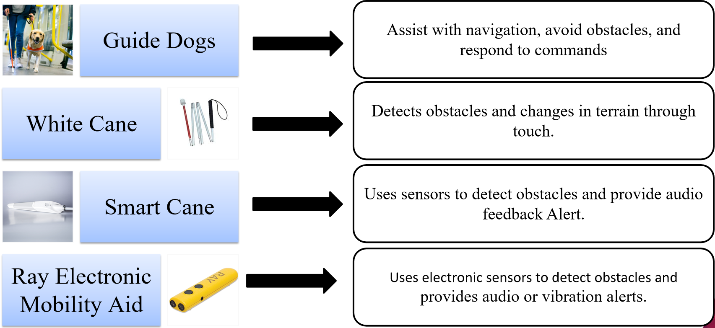
Fig.3.1 Existing System

3.2 PROPOSED SYSTEM:
The project is designed to overcome all these disadvantages and come up with best solution by placing a camera panel for distance of the objects, all the objects get detected. Such that person can know the object before reaching it. The image processing technology is used here to get the text from the images. By the usage of sensors, we increase the pin point accuracy. The project is built around the Raspberry pi it provides all the functionality and control. This project uses regulated a battery. Voltage regulator is used for voltage regulation.

Camera Input and Image Capture: The system utilizes a wearable camera to continuously capture images of the user’s surroundings. The camera is designed to be lightweight and unobtrusive, mounted on a user-friendly device like glasses, or a cap. The captured images are stored in real-time for further processing.
Pre-Processing of the Image: Once the image is captured, the system applies pre-processing techniques to enhance the quality of the image for easier analysis. This includes noise reduction, normalization of brightness and contrast, and edge detection to highlight the important features in the scene. Pre-processing ensures that the system can accurately identify and classify objects within the environment.
Object Identification: Using advanced machine learning algorithms, such as deep learning models trained for object detection, the system identifies and classifies objects within the pre-processed image. These objects may include common obstacles like furniture, walls, doors, or even people, which are crucial for the user’s navigation. The identification is based on the trained model that recognizes various objects and assigns labels to them in real-time.
Generate Audio Signal: After identifying the object, the system generates an audio signal or voice feedback that corresponds to the recognized object. The audio output is designed to be clear and concise, indicating the type and location of the object. For example, if an object is detected ahead, an audio message may say, "Obstacle detected in front." The user can then take appropriate action based on this feedback
Audio Output: The audio feedback is delivered through a pair of wireless earphones or bone conduction headphones, allowing the user to hear the information without obstructing their surroundings. The audio output can be adjusted for volume and clarity, ensuring that the user receives real-time information in a manner that is both non-intrusive and helpful for navigation.

3.3 INTRODUCTION OF EMBEDDED SYSTEM:
An Embedded System is a combination of computer hardware and software, and perhaps additional mechanical or other parts, designed to perform a specific function. A good example is the microwave oven. Almost every household has one, and tens of millions of them are used every day, but very few people realize that a processor and software are involved in the preparation of their lunch or dinner.
This is in direct contrast to the personal computer in the family room. It too is comprised of computer hardware and software and mechanical components (disk drives, for example). However, a personal computer is not designed to perform a specific function rather; it is able to do many different things. Many people use the term general-purpose computer to make this distinction clear. As shipped, a general-purpose computer is a blank slate; the manufacturer does not know what the customer will do wish it. One customer may use it for a network file server another may use it exclusively for playing games, and a third may use it to write the next great American novel.
Frequently, an embedded system is a component within some larger system. For example, modern cars and trucks contain many embedded systems. One embedded system controls the anti-lock brakes, other monitors and controls the vehicle's emissions, and a third displays information on the dashboard. In some cases, these embedded systems are connected by some sort of a communication network, but that is certainly not a requirement.
At the possible risk of confusing you, it is important to point out that a general-purpose computer is itself made up of numerous embedded systems. For example, my computer consists of a keyboard, mouse, video card, modem, hard drive, floppy drive, and sound card-each of Which is an embedded system? Each of these devices contains a processor and software and is designed to perform a specific function. For example, the modem is designed to send and receive digital data over analog telephone line. That's it and all of the other devices can be summarized in a single sentence as well.
If an embedded system is designed well, the existence of the processor and software could be completely unnoticed by the user of the device. Such is the case for a microwave oven, VCR, or alarm clock. In some cases, it would even be possible to build an equivalent device that does not contain the processor and software. This could be done by replacing the combination with a custom integrated circuit that performs the same functions in hardware. However, a lot of flexibility is lost when a design is hard-cooled in this way. It is much easier, and cheaper, to change a few lines of software than to redesign a piece of custom hardware.

3.3.1 Real Time Systems:
One subclass of embedded is worthy of an introduction at this point. As commonly defined, a real-time system is a computer system that has timing constraints. In other words, a real-time system is partly specified in terms of its ability to make certain calculations or decisions in a timely manner. These important calculations are said to have deadlines for completion. And, for all practical purposes, a missed deadline is just as bad as a wrong answer. The issue of what if a deadline is missed is a crucial one. For example, if the real-time system is part of an airplane's flight control system, it is possible for the lives of the passengers and crew to be endangered by a single missed deadline. However, if instead the system is involved in satellite communication, the damage could be limited to a single corrupt data packet. The more severe the consequences, the more likely it will be said that the deadline is "hard" and thus, the system is a hard-real-time system. Real-time systems at the other end of this discussion are said to have "soft" deadlines.
All of the topics and examples presented in this book are applicable to the designers of real-time system who is more delight in his work. He must guarantee reliable operation of the software and hardware under all the possible conditions and to the degree that human lives depend upon three system's proper execution, engineering calculations and descriptive paperwork.
Application Areas: Nearly 99 per cent of the processors manufactured end up in embedded systems. The embedded system market is one of the highest growth areas as these systems are used in very market segment consumer electronics, office automation, industrial automation, biomedical engineering, wireless communication, Data communication, telecommunications, transportation, military and so on.

3.3.2 Overview of Embedded System Architecture
Every embedded system consists of custom-built hardware built around a Central Processing Unit (CPU). This hardware also contains memory chips onto which the software is loaded. The software residing on the memory chip is also called the ‘firmware’. The embedded system architecture can be represented as a layered architecture as shown in Fig.
The operating system runs above the hardware, and the application software runs above the operating system. The same architecture is applicable to any computer including a desktop computer. However, there are significant differences. It is not compulsory to have an operating system in every embedded system.For small appliances such as remote-control units, air conditioners, toys etc., there is no need for an operating system and you can write only the software specific to that application. For applications involving complex processing, it is advisable to have an operating system. In such a case, you need to integrate the application software with the operating system and then transfer the entire software on to the memory chip. Once the software is transferred to the memory chip, the software will continue to run fora long time you don’t need to reload new software.
Now, let us see the details of the various building blocks of the hardware of an embedded system. As shown in Fig. the building blocks are:
- Central Processing Unit (CPU)
- Memory (Read-only Memory and Random-Access Memory)
- Input Devices
- Output devices
- Communication interfaces
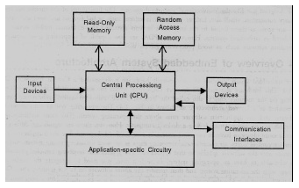
- Application-specific circuitry
Fig 3.3.2 Blocks of hardware embedded system
Central Processing Unit (CPU): The Central Processing Unit (processor, in short) can be any of the following: microcontroller, microprocessor or Digital Signal Processor (DSP). A micro-controller is a low-cost processor. Its main attraction is that on the chip itself, there will be many other components such as memory, serial communication interface, analog-to digital converter etc. So, for small applications, a micro-controller is the best choice as the number of external components required will be very less. On the other hand, microprocessors are more powerful, but you need to use many external components with them. D5P is used mainly for applications in which signal processing is involved such as audio and video processing.
Memory: The memory is categorized as Random Access 11emory (RAM) and Read Only Memory (ROM). The contents of the RAM will be erased if power is switched off to the chip, whereas ROM retains the contents even if the power is switched off. So, the firmware is stored in the ROM. When power is switched on, the processor reads the ROM; the program is program is executed.
Input devices: Unlike the desktops, the input devices to an embedded system have very limited capability. There will be no keyboard or a mouse, and hence interacting with the embedded system is no easy task. Many embedded systems will have a small keypad-you press one key to give a specific command. A keypad may be used to input only the digits. Many embedded systems used in process control do not have any input device for user interaction; they take inputs from sensors or transducers 1’fnd produce electrical signals that are in turn fed to other systems.
Output devices: The output devices of the embedded systems also have very limited capability. Some embedded systems will have a few Light Emitting Diodes (LEDs) to indicate the health status of the system modules, or for visual indication of alarms. A small Liquid Crystal Display (LCD) may also be used to display some important parameters.
Communication interfaces: The embedded systems may need to, interact with other embedded systems at they may have to transmit data to a desktop. To facilitate this, the embedded systems are provided with one or a few communication interfaces such as RS232, RS422, RS485, Universal Serial Bus (USB), IEEE 1394, Ethernet etc.
3.4 BLOCK DIAGRAM OF PROJECT AND FUNCTIONING:

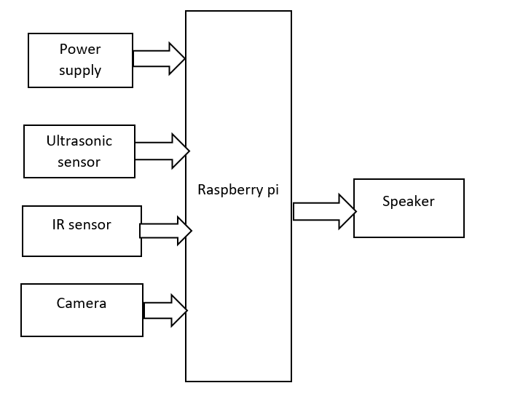
Fig.3.4 Block Diagram of Project
The flowchart illustrates the working of the smart wearable system. It starts with powering on the Raspberry Pi and initializing the camera and ultrasonic sensors. The system continuously captures real-time video and checks for obstacles using both image processing and distance measurement. If an obstacle is detected within a critical range, the object is identified using a deep learning model. The Raspberry Pi processes this information and sends voice feedback to the user through earphones. The cycle repeats continuously, providing real-time assistance for safe navigation.

CHAPTER 4
DESCRPTION OF COMPONENTS
4.1 RASPBERRY PI BOARD:
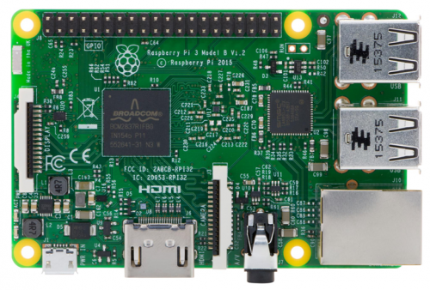
Fig.4.1 Raspberry Pi 3 Board

4.1.1 Bcm2837 Features
A Raspberry Pi 4 board contains BCM2837 controller which supports ARM11 processing unit. This is the Broadcom chip used in the Raspberry Pi 4, and in later models of the Raspberry Pi 2. The underlying architecture of the BCM2837 is identical to the BCM2836. The only significant difference is the replacement of the ARMv7 quad core cluster with a quad-core ARM Cortex A53 (ARMv8) cluster.The ARM cores run at 1.2GHz, making the device about 50% faster than the Raspberry Pi 2. The VideocoreIV runs at 400Mhz.
The Raspberry Pi 4 Model B builds upon the features of its predecessors with a new, faster processor on board to increase its speed. It also features WiFi and Bluetooth Low Energy capabilities to enhance the functionality and the ability to power more powerful devices over the USB ports [20].
- Quad Core 1.2GHz Broadcom BCM2837 64bit CPU
- 1GB RAM
- BCM43143 WiFi and Bluetooth Low Energy (BLE) on board
- 40-pin Extended GPIO
- 4x USB 2 ports
- 4 Pole stereo output and composite video port
- Full size HDMI
- CSI camera port for connecting a Raspberry Pi camera
- DSI display port for connecting a Raspberry Pi touchscreen display
- Micro SD port for loading your operating system and storing data.
4.1.2 Pin Diagram of Raspberry Pi
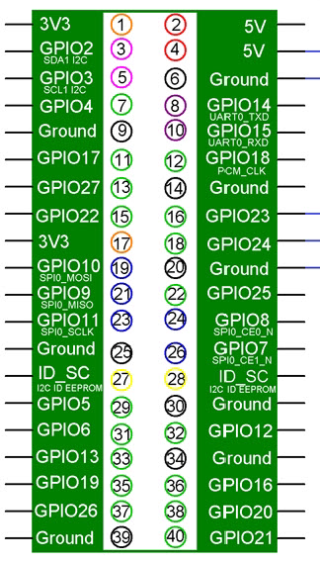
Fig.4.1.2 pin diagram of raspberry pi

GPIO Is Your Standard Pins That Simply Be Used to Turn Devices an And Off. For Example, A LED.
I2C (Inter-Integrated Circuit) Pins Allow You to Connect and Talk to Hardware Modules That Support This Protocol (I2C Protocol). This Protocol Will Typically Take Up Two Pins.
SPI (Serial Peripheral Interface Bus) Pins Can Be Used to Connect and Talk to SPI Devices. Pretty Much the Same as I2C But Makes Use of a Different Protocol.
UART (Universal Asynchronous Receiver/Transmitter) Is The Serial Pins Used To Communicate With Other Devices.
DNC Stands for Do Not Connect, This Is Pretty Self-Explanatory.
The Power Pins Pull Power Directly from The Raspberry Pi.
GND Are the Pins You Use to Ground Your Devices. It Doesn’t Matter Which Pin You Use as They Are All Connected to The Same Line

4.1.3 Features of Raspberry Pi Pin:
- Broadcom BCM2837 64bit ARM Cortex-A53 Quad Core Processor Soc Running @ 1.2ghz
- 1 GB RAM
- 4 X USB2.0 Ports with Up To 1.2A Output
- Expanded 40-Pin GPIO Header
- Video/Audio Out Via 4-Pole 3.5mm Connector, HDMI, CSI Camera, Or Raw LCD (DSI)
- Storage: Microsd
- 10/100 Ethernet (RJ45)
- BCM43143 Wifi On Board 802.11n Wireless LAN
- Bluetooth Low Energy (BLE) On Board (Bluetooth 4.1)
  - 27 X GPIO
  - UART
  - I2C Bus
  - SPI Bus with Two Chip Selects
  - +3.3V
  - +5V
  - Ground
- Power Requirements: 5V @ 2.4 A Via Microusb Power Source
- Supports Raspbian, Windows 10 Iot Core, Openelec, OSMC, Pidora, Arch Linux, RISC OS And More.
  - Complete Compatibility with Raspberry Pi 1 And 2

4.1.4 Raspberry Pi Basic Hardware Setup
- Extra Hardware You Will Need
- The Raspberry Pi Board Contains A Processor and Graphics Chip, Program Memory (RAM) And Various Interfaces and Connectors for External Devices. Some of These Devices Are Essential, Others Are Optional. It Operates in The Same Way as A Standard PC, Requiring A Keyboard for Command Entry, A Display Unit and A Power Supply.
- Since Raspberry Pi Board Operates Like PC It Requires ‘Mass-Storage’, But A Hard Disk Drive of The Type Found in A Typical PC Is Not Really in Keeping with The Miniature Size of Rpi.
- Instead We Will Use an SD Flash Memory Card Normally Used in Digital Cameras, Configured in Such A Way To ‘Look Like’ A Hard Drive to Rpi’s Processor.
- Rpi Will ‘Boot’ (Load The Operating System Into RAM) From This Card in The Same Way as A PC ‘Boots Up’ Into Windows from Its Hard Disk.
- The Following Are Essential to Get Started:
• SD Card Containing Linux Operating System
• USB Keyboard
• TV Or Monitor (With HDMI, DVI, Composite or SCART Input)
• Power Supply (See Section 1.6 Below)
• Video Cable to Suit the TV Or Monitor Used

4.1.5 Operating System In SD Card
- As the Rpi Has No Internal Mass Storage or Built-In Operating System It Requires an SD Card Preloaded with A Version Of The Linux Operating System.
- You Can Create Your Own Preloaded Card Using Any Suitable SD Card (4gbytes Or Above) You Have to Hand. We Suggest You Use A New Blank Card to Avoid Arguments Over Lost Pictures.
4.1.6 Devices with Known Issues:
Interoperability Between the Raspberry Pi and USB3.0 Hubs: There is an Issue with USB3.0 Hubs in Conjunction with The Use of Full- Or Low-Speed Devices (Most Mice, Most Keyboards) And the Raspberry Pi. A Bug in Most USB3.0 Hub Hardware Means That the Raspberry Pi Cannot Talk in Full- Or Low-Speed Devices Connected to a USB3.0 Hub. USB2.0 High-Speed Devices, Including USB2.0 Hubs, Operate Correctly When Connected Via A USB3.0 Hub. Avoid Connecting Low- Or Full-Speed Devices into A USB3.0 Hub. As A Workaround, Plug A USB2.0 Hub into The Downstream Port of The USB3.0 Hub and Connect the Low-Speed Device, Or Use A USB2.0 Hub Between the Pi and The USB3.0 Hub, Then Plug Low-Speed Devices into The USB2.0 Hub.
USB: Old Webcams May Be Full-Speed Devices. Because These Devices Transfer A Lot of Data and Incur Additional Software Overhead, Reliable Operation Is Not Guaranteed. As A Workaround, Try to Use the Camera at a Lower Resolution.
Esoteric USB Sound Cards: Expensive "Audiophile" Sound Cards Typically Use Far More Bandwidth Than Is Necessary to Stream Audio Playback. Reliable Operation With 96khz/192khz Dacs Is Not Guaranteed.As A Workaround, Forcing the Output Stream to Be CD Quality (44.1khz/48khz 16-Bit) Will Reduce the Stream Bandwidth to Reliable Levels.
Single-TT USB Hubs: USB2.0 And 3.0 Hubs Have A Mechanism for Talking to Full- Or Low-Speed Devices Connected to Their Downstream Ports Called A Transaction Translator. This Device Buffers High-Speed Requests from The Host (I.E. The Pi) And Transmits Them at Full- Or Low-Speed to The Downstream Device. Two Configurations of Hub Are Allowed by The USB Specification: Single-TT (One TT for All Ports) And Multi-TT (One TT Per Port).
Because Of The OTG Hardware Limitations, If Too Many Full- Or Low-Speed Devices Are Plugged into A Single-TT Hub, Unreliable Operation of The Devices May Occur. It Is Recommended to Use a Multi-TT Hub to Interface with Multiple Lower-Speed Devices. As A Workaround, Spread Lower-Speed Devices Out Between the Pi's Own USB Port and The Single-TT Hub.

4.2 POWER SUPPLY
Step down Transformer
Filter
Regulator
Output
Bridge Rectifier

The input to the circuit is applied from the regulated power supply. The a.c. input i.e., 230V from the mains supply is step down by the transformer to 12V and is fed to a rectifier. The output obtained from the rectifier is a pulsating d.c voltage. so in order to get a pure d.c voltage, the output voltage from the rectifier is fed to a filter to remove any a.c components present even after rectification. Now, this voltage is given to a voltage regulator to obtain a pure constant dc voltage.
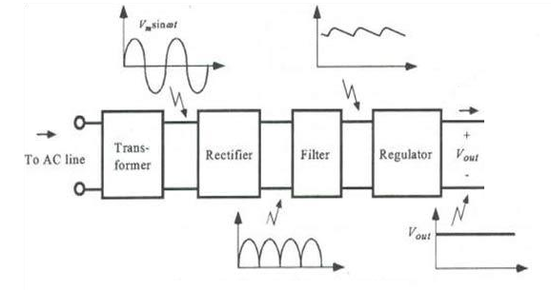
Fig 4.2 Block Diagram of Power supply
Fig 4.2.1 Circuit Diagram of Power supply
4.2.1 Step down Transformer: Usually, DC voltages are required to operate various electronic equipment and these voltages are 5V, 9V or 12V. But these voltages cannot be obtained directly. Thus, the a.c input available at the mains supply i.e., 230V is to be brought down to the required voltage level. This is done by a transformer. Thus, a step-down transformer is employed to decrease the voltage to a required level.
4.2.2 Rectifier:
The output from the transformer is fed to the rectifier. It converts A.C. into pulsating D.C. The rectifier may be a half wave or a full wave rectifier. In this project, a bridge rectifier is used because of its merits like good stability and full wave rectification.
4.2.3 Filter:
Capacitive filter is used in this project. It removes the ripples from the output of rectifier and smoothens the D.C. Output received from this filter is constant until the mains voltage and load is maintained constant. However, if either of the two is varied, D.C. voltage received at this point changes. Therefore, a regulator is applied at the output stage.
4.2.4 Voltage Regulator:
As the name itself implies, it regulates the input applied to it. A voltage regulator is an electrical regulator designed to automatically maintain a constant voltage level. In this project, power supply of 5V and 12V are required. In order to obtain these voltage levels, 7805 and 7812 voltage regulators are to be used. The first number 78 represents positive supply and the numbers 05, 12 represent the required output voltage levels.
Features:
• Output Current up to 1A.
• Output Voltages of 5, 6, 8, 9, 10, 12, 15, 18, 24V.
• Thermal Overload Protection
• Short Circuit Protection.
• Output Transistor Safe Operating Area Protection.
4.3 WEB CAMERA
Camera plays a vital role in automation purpose. The camera is used for monitoring of a room from a remote place. The camera used is a USB camera (life cam vx-800). Whenever the user clicks on to video button on loaded webpage, the corresponding room video will be streamed on to webpage. for this purpose, we use a MJPG streamer. The below figure shows the camera that has been used for monitoring of a room.
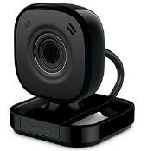



4.4 SPEAKER:
Computer speakers, or multimedia speakers, are speakers sold for use with computers, although usually capable of other audio uses, e.g. for an MP3 player. Most such speakers have an internal amplifier and consequently require a power source, which may be by a mains power supply often via an AC adapter, batteries, or a USB port. The signal input connector is often a 3.5 mm jack plug (usually color-coded lime green per the PC 99 standard); RCA connectors are sometimes used, and a USB port may supply both signal and power (requiring additional circuitry, and only suitable for use with a computer). Battery-powered wireless Bluetooth speakers require no connections at all. Most computers have speakers of low power and quality built in; when external speakers are connected they disable the built-in speakers. Altec Lansing claims to have created the computer speaker market in 1990.^{[1]}
Computer speakers range widely in quality and in price. Computer speakers sometimes packaged with computer systems are small, plastic, and have mediocre sound quality. Some computer speakers have equalization features such as bass and treble controls. Bluetooth speakers can be connected with a computer by using an Aux jack and compatible adaptor.^{[2]}
More sophisticated computer speakers can have a subwoofer unit, to enhance bass output. The larger subwoofer enclosure usually contains the amplifiers for the subwoofer and the left and right speakers.
Some computer displays have rather basic speakers built-in. Laptop computers have built-in integrated speakers, usually small and of restricted sound quality to conserve space. Instead of using a computer speaker for better sound, a computer can be connected to any external sound system, typically a high-power high-quality setup.
  - ULTRASONIC SENSOR:
Ultrasonic sensors (also known as transceivers when they both send and receive) work on a principle similar to radar or sonar which evaluate attributes of a target by interpreting the echoes from radio or sound waves respectively. Ultrasonic sensors generate high frequency sound waves and evaluate the echo which is received back by the sensor. Sensors calculate the time interval between sending the signal and receiving the echo to determine the distance to an object.
This technology can be used for measuring: wind speed and direction (anemometer), fullness of a tank and speed through air or water. For measuring speed or direction a device uses multiple detectors and calculates the speed from the relative distances to particulates in the air or water. To measure the amount of liquid in a tank, the sensor measures the distance to the surface of the fluid. Further applications include: humidifiers, sonar, medical ultrasonography, burglar alarms and non-destructive testing.
Systems typically use a transducer which generates sound waves in the ultrasonic range, above 18,000 hertz, by turning electrical energy into sound, then upon receiving the echo turn the sound waves into electrical energy which can be measured and displayed.
- VCC -> Arduino +5V pin
- GND -> Arduino GND pin
- Trig -> Arduino Digital Pin 2
- Echo -> Arduino Digital Pin 2
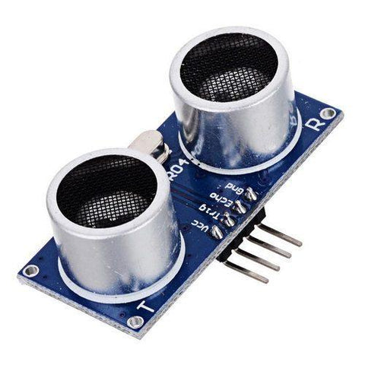
Fig.4.5 Ultrasonic sensors

Features
- Detecting range: 3cm-4m
- Best in 30 degree angle
- Electronic brick compatible interface
- 5VDC power supply
- Breadboard friendly
- Dual transducer
- Arduino library ready

Specification
Supply voltage | 5V
Global Current Consumption | 15 mA
Ultrasonic Frequency | 40k Hz
Maximal Range | 400 cm
Minimal Range | 3 cm
Resolution | 1 cm
Trigger Pulse Width | 10 μs
Outline Dimension | 43x20x15 mm

Usage

Hardware Installation
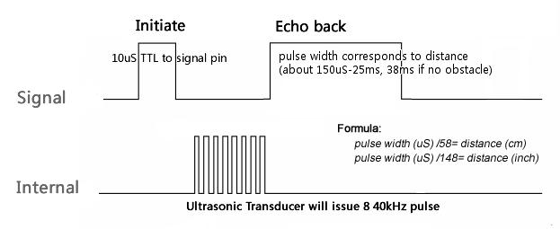
A short ultrasonic pulse is transmitted at the time 0, reflected by an object. The senor receives this signal and converts it to an electric signal. The next pulse can be transmitted when the echo is faded away. This time period is called cycle period. The recommend cycle period should be no less than 50ms. If a 10μs width trigger pulse is sent to the signal pin, the Ultrasonic module will output eight 40kHz ultrasonic signal and detect the echo back. The measured distance is proportional to the echo pulse width and can be calculated by the formula above. If no obstacle is detected, the output pin will give a 38ms high level signal.

4. SOFTWARE

REQUIRED ITEMS
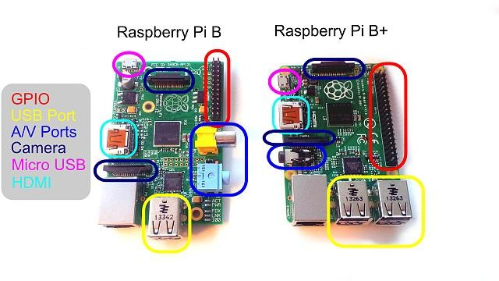
- A Raspberry Pi (Either a Model B or Model B+)
- SD Card
  - We recommend an 8GB class 4 SD card.
- Display and connecting cables
  - Any HDMI/DVI monitor or TV should work as a display for the Pi.
  - For best results, use one with HDMI input, but other connections are available for older devices.
- Keyboard and mouse
  - Any standard USB keyboard and mouse will work with your Raspberry Pi.
- Power supply
  - Use a 5V micro USB power supply to power your Raspberry Pi. Be careful that whatever power supply you use outputs at least 5V; insufficient power will cause your Pi to behave unexpectedly.
- Internet connection
  - To update or download software, we recommend that you connect your Raspberry Pi to the internet either via an Ethernet cable or a WiFi adaptor.
- Sound
  - Headphones, earphones or speakers with a 3.5mm jack will work with your Raspberry Pi.
RASPBERRY PI

INSTALLING RASBIAN DEBIAN WHEEZY OPERATING SYSTEM USING WINDOWS

- http://downloads.raspberrypi.org/raspbian_latest
Dowload the file “RASPBIAN Debian Wheezy.zip” and extract the image file.
- Insert the SD card into your SD card reader(format the sd card) and check which drive letter was assigned. You can easily see the drive letter (for example G:) by looking in the left column of Windows Explorer. You can use the SD Card slot (if you have one) or a cheap SD adaptor in a USB port.
- Download the Win32DiskImager utility from the Sourceforge Project page (it is also a zip file); you can run this from a USB drive. http://sourceforge.net/projects/win32diskimager/files/latest/download
- Extract the executable from the zip file and run the Win32DiskImager utility; you may need to run the utility as administrator. Right-click on the file, and select Run as administrator.
- Select the image file you extracted above.
- Select the drive letter of the SD card in the device box. Be careful to select the correct drive; if you get the wrong one you can destroy your data on the computer's hard disk! If you are using an SD card slot in your computer and can't see the drive in the Win32DiskImager window, try using a cheap SD adaptor in a USB port.
- Click Write and wait for the write to complete.
- Exit the imager and eject the SD card
FORMAT THE SD CARD
Locate your SD card drive, in Windows Explorer, and secondary-click the mouse to bring up the context-senstive menu. From the menu select Format…. Ensure that the option FAT32 (Default) is selected and click Start.
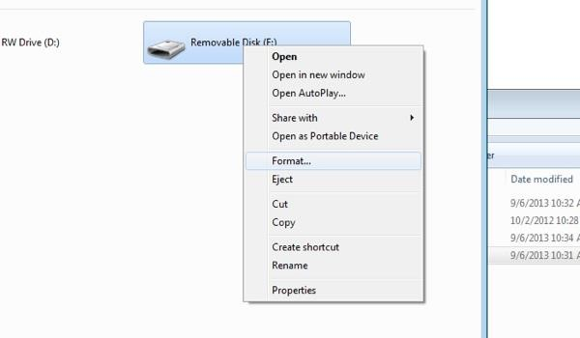
Selecting an SD card to format
A few moments later you will see a confirmation that the format has been completed and you SD card is now ready for the next stage.
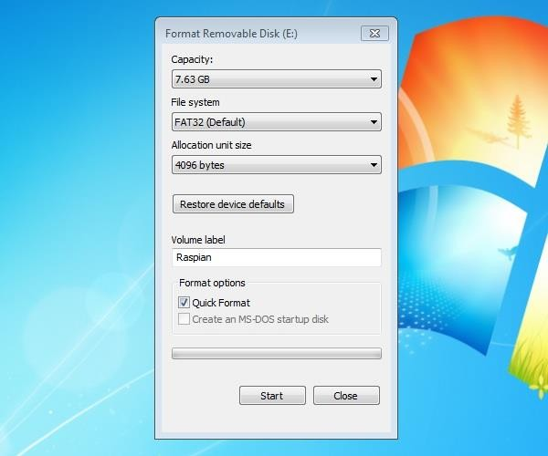
Formatting the SD card
USING WIN32DISKIMAGER
Having plugged in your SD card, (re)start Win32Diskimager. Choose the drive you want to copy the image to (in my case F:).

- choose the drive with your SD card to write the OS image on
Then click on the folder icon and choose the unzipped .img file from earlier that you want to put on the SD card. Then click Write, to write the Operating system on the card from the .img file.
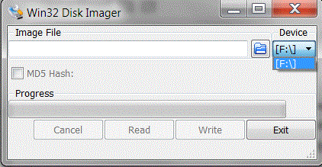

- Write OS image from .img file to SD card
You will then be asked to confirm. Check carefully that you are writing to the correct device and if so, click Yes.
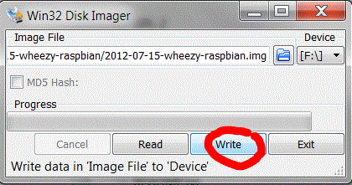

- Check device and confirm
The progress bar will show you how far it’s got.
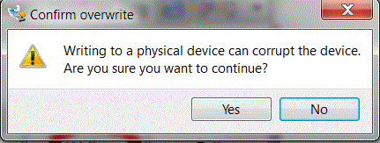
Progress indicator
When it’s finished it looks like this.
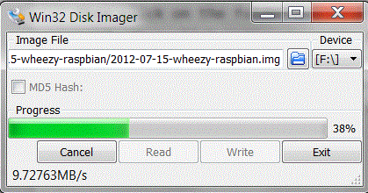

- Finished
Then you can eject the card reader and remove the SD card. Then you can try it out in your Raspberry Pi
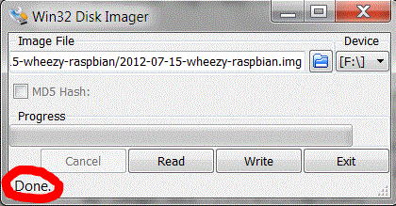
PLUGGING IN YOUR RASPBERRY PI
- Begin by slotting your SD card into the SD card slot on the Raspberry Pi, which will only fit one way.
- Next, plug in your USB keyboard and mouse into the USB slots on the Raspberry Pi. Make sure that your monitor or TV is turned on, and that you have selected the right input (e.g. HDMI 1, DVI, etc).

- Then connect your HDMI cable from your Raspberry Pi to your monitor or TV.

- If you intend to connect your Raspberry Pi to the internet, plug in an Ethernet cable into the Ethernet port next to the USB ports; if you do not need an internet connection, skip this step.
- Finally, when you are happy that you have plugged in all the cables and SD card required, plug in the micro USB power supply. This action will turn on and boot your Raspberry Pi.
- If this is the first time your Raspberry Pi SD card have been used, then you will have to select an operating system and configure it.

LOGGING INTO YOUR RASPBERRY PI

- Once your Raspberry Pi has completed the boot process, a login prompt will appear. The default login for Raspbian is username pi with the password raspberry. Note you will not see any writing appear when you type the password. This is a security feature in Linux.
- After you have successfully logged in, you will see the command line prompt pi@raspberrypi~$.

- To load the graphical user interface, type startx and press Enter on your keyboard.
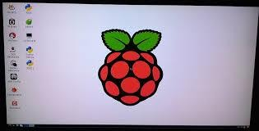
DOWNLOAD AND INSTALL WIRING PI

WiringPi is maintained under GIT for ease of change tracking, however there is a Plan B if you’re unable to use GIT for whatever reasons (usually your firewall will be blocking you, so do check that first!)

ONLINE INSTALL
If you do not have GIT installed, then under any of the Debian releases (e.g. Raspbian), you can install it with:

sudo apt-get install git-core
If you get any errors here, make sure your Pi is up to date with the latest versions of Raspbian:

sudo apt-get update sudo apt-get upgrade

To obtain WiringPi using GIT:

git clone git://git.drogon.net/wiringPi
If you have already used the clone operation for the first time, then

cd wiringPi git pull origin
Will fetch an updated version then you can re-run the build script below. To build/install there is a new simplified script:

cd wiringPi
./build
The new build script will compile and install it all for you – it does use the sudo command at one point, so you may wish to inspect the script before running it.

OFFLINE INSTALL

Click on this URL: (it should open in a new page)

https://git.drogon.net/?p=wiringPi;a=summary

Then look for the link marked snapshot at the right-hand side. You want to click on the top one.
This will download a tar.gz file with a name like wiringPi-98bcb20.tar.gz. Note that the numbers and letters after wiringPi (98bcb20 in this case) will probably be different – they’re a unique identifier for each release.

You then need to do this to install:

tar xfz wiringPi-98bcb20.tar.gz cd wiringPi-98bcb20
./build
Note that the actual filename will be different – you will have to check the name and adjust according

5.RESULT

Add kit photo

- CONCLUSION
To enable obstacle detection and alarm systems, the suggested smart wearable gadget for the blind incorporates Raspberry Pi and ultrasonic sensors. This technology improves independence, safety, and mobility by providing real-time feedback. It is a useful and efficient assistive device because of its wearable design, which guarantees simplicity of use. Future enhancements could incorporate GPS integration for improved navigation and AI-based item identification. With technology-driven solutions, this breakthrough is a major step toward empowering those with visual impairments.
The aim of Blind project is to create a device that is useful for visually impaired individuals, allowing them to navigate their surroundings with greater confidence and independence. The device consists of a wearable band that uses ultrasonic waves to detect nearby obstacles and notifies the user with a buzzer sound. This allows users to move around freely and avoid obstacles that they might not have been able to detect otherwise. The device utilizes an detect obstacles and a Raspberry Pi to provide instructions through a voice assistant that has been programmed by the developers. In the future, there is potential to further improve the device by adding new features such as directional and warning messages to prevent accidents, battery level notifications, video detection to enhance the user's experience, a mobile application.

7. REFERENCES
- Steinmetz, J.D.; Bourne, R.R.; Briant, P.S.; Flaxman, S.R.; Taylor, H.R.; Jonas, J.B.; Abdoli, A.A.; Abrha, W.A.; Abualhasan, A.; Abu-Gharbieh, E.G.; et al. Causes of blindness and vision impairment in 2020 and trends over 30 years, and prevalence of avoidable blindness in relation to VISION 2020: The Right to Sight: An analysis for the Global Burden of Disease Study. Lancet Glob. Health 2021, 9, e144–e160. [Google Scholar] [CrossRef]

- Dunai Dunai, L.; Chillarón Pérez, M.; Peris-Fajarnés, G.; Lengua Lengua, I. Euro banknote recognition system for blind people. Sensors 2017, 17, 184. [Google Scholar] [CrossRef] [PubMed][Green Version]

- Lee, J.; Ahn, J.; Lee, K.Y. Development of a raspberry Pi-based banknote recognition system for the visually impaired. J. Soc. E-Bus. Stud. 2018, 23, 21–31. [Google Scholar]
- Patrycja, B.-A.; Osiński, D.; Wierzchoń, M.; Konieczny, J. Visual Echolocation Concept for the Colorophone Sensory Substitution Device Using Virtual Reality. Sensors 2021, 21, 237. [Google Scholar]
- Chang, W.-J.; Chen, L.-B.; Sie, C.-Y.; Yang, C.-H. An artificial intelligence edge computing-based assistive system for visually impaired pedestrian safety at zebra crossings. IEEE Trans. Consum. Electron. 2020, 67, 3–11. [Google Scholar] [CrossRef]
- Yu, S.; Lee, H.; Kim, J. Street crossing aid using light-weight CNNs for the visually impaired. In Proceedings of the IEEE/CVF International Conference on Computer Vision Workshops, Seoul, Korea, 27–28 October 2019. [Google Scholar]
- Yuksel, B.F.; Fazli, P.; Mathur, U.; Bisht, V.; Kim, S.J.; Lee, J.J.; Jin, S.J.; Siu, Y.-T.; Miele, J.A.; Yoon, I. Human-in-the-Loop Machine Learning to Increase Video Accessibility for Visually Impaired and Blind Users. In Proceedings of the 2020 ACM Designing Interactive Systems Conference, Eindhoven, The Netherlands, 6–10 July 2020. [Google Scholar]
- Liu, X.; Carrington, P.; Chen, X.A.; Pavel, A. What Makes Videos Accessible to Blind and Visually Impaired People? In Proceedings of the 2021 CHI Conference on Human Factors in Computing Systems, Yokohama, Japan, 8–13 May 2021. [Google Scholar]
- Spagnol, S.; Hoffmann, R.; Martínez, M.H.; Unnthorsson, R. Blind wayfinding with physically-based liquid sounds. Int. J. Hum.-Comput. Stud. 2018, 115, 9–19. [Google Scholar] [CrossRef][Green Version]
- Skulimowski, P.; Owczarek, M.; Radecki, A.; Bujacz, M.; Rzeszotarski, D.; Strumillo, P. Interactive sonification of U-depth images in a navigation aid for the visually impaired. J. Multimodal User Interfaces 2019, 13, 219–230. [Google Scholar] [CrossRef][Green Version]
- Zhao, Y.; Wu, S.; Reynolds, L.; Azenkot, S. A face recognition application for people with visual impairments: Understanding use beyond the lab. In Proceedings of the 2018 CHI Conference on Human Factors in Computing Systems, Montreal, QC, Canada, 21–26 April 2018. [Google Scholar]

